**A PROJECT ON**

**Complaint Management System**

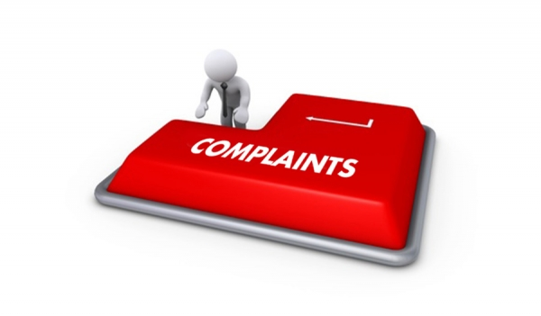



**ATAL BIHARI VAJPAYEE-**

**INDIAN INSTITUTE OF INFORMATION TECHNOLOGY AND MANAGEMENT,GWALIOR**

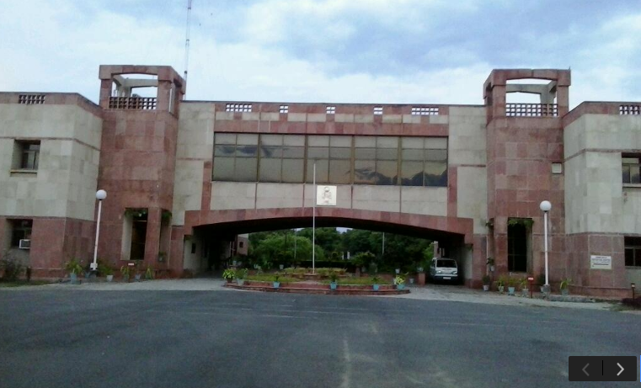

**Submitted to:-**

**Dr. Ajay Kumar**

**(Associate Professor)**

**Submitted by:**

**Sahil IPG-2016089**

**Sanjit Prasad IPG-2016091**

**Shashank Swarup sharma IPG-2016097**

**Surendra Singh Gangwar IPG-2016107**

**Acknowledgement**

The success and final outcome of this project required a lot of guidance and assistance from many people and we am extremely privileged to have got this all along the completion of my project. All that we have done is only due to such supervision and assistance and we would not forget to thank them.

First we respect and thank, **Dr. Ajay Kumar,** Atal Bihari Vajpayee Indian Institute of Information Technology and Management, for providing us an opportunity to do the project work and giving us all support for his insightful advice, motivating suggestions, valuable guidance, help and lots of moral support in successful completion of this Project and also for his constant encouragement and advice throughout our IPG (Information Technology) programme.

I would like to thank all other teaching staff for their valuable teaching and constant advice which helped us to finish this program successfully.

My thanks and appreciations also go to my colleague in developing the project and people who have willingly helped me out with their abilities.

**Abstract**

A Complaint Management System is one of latest productivity enhancement tools used widely by all organizations. This Complaint Portal focuses on providing a common platform to all the students to report any complaints. Our website is an online complaint management system where the issues of the students can be registered online and resolved by the different levels of engineers. Reduction of paper movements provides complaint management operations a speed which was never envisaged in manual mode at all.

**TABLE OF CONTENTS**

|  |  |  |
| --- | --- | --- |
| Chapter | Topic | Page No. |
| 1 | **Introduction** |  |
| 2 | **Project Selection and Planning** |  |
| 2.1 | Need Of System |  |
| 2.2 | Scope |  |
| 3 | **General Description** |  |
| 3.1 | Product Perspective |  |
| 3.2 | Product features |  |
| 3.3 | Design and Implementation Constraints |  |
| 3.4 | Assumptions |  |
| 4 | **Software Requirement Specifications ( SRS )** |  |
| 4.1 | Business Drivers |  |
| 4.2 | System Qualities |  |
| 5 | **Interface Requirements** |  |
| 5.1 | User Interface |  |
| 5.2 | Hardware Interface |  |
| 5.3 | Software Interface |  |
| 6 | **Functional Requirement** |  |
| 7 | **Non function Requirement** |  |
| 7.1 | Performance |  |
| 7.2 | Security |  |
| 7.3 | Operational |  |
| 8 | **Software development Model** |  |
| 9 | **Use Cases** |  |
| 10 | **Data Flow Diagrams** |  |
| 11 | **Various Cost In Developing Project** |  |
| 11.1 | Maintainance cost |  |
| 11.2 | Labour Cost |  |
| 11.3 | Material Cost |  |
| 11.4 | Service Cost |  |
| 12 | **Conclusion** |  |

1. **Introduction**

A complaint system is a set of procedures used in organizations to address complaints and resolve disputes. Complaint systems in the India have undergone several innovations especially since about 1990 with the advent of extensive workplace regulation. Notably in many countries, conflict management channels and systems have evolved from a major focus on labor-management relations to a much wider purview that includes unionized workers and also managers, non-union employees, professional staff, students, trainees etc.

There is also a major need to collect, review and understand the nature of conflict management and complaint systems around the world. Studies and citations are needed about how complaint systems work for all. This Complaint Portal is for the automation of Complaints Management.

1. **Project Selection and Planning**
   1. **Need of System**

➢ The existing facility of registering Hostel related complaints is cumbersome.Students have to wait for Supervisor to come to the Hostel which causes the delay for complaints reaching to the concerned department. There is a need to deploy an online complaint system so that students can register their complaints directly to the concerned department.

**2.2 Scope**

* The proposed software product is the Complaint Management System(CMS). The system will have following objectives.
* The objectives of the system are:
* Getting complaints from students regarding problems in room, electricity, washroom, internet etc.
* Forwarding complaints directly to concerned authority.
* Requirement statements in this document are both functional and non-functional.

**3. General Description**

**3.1 Product Perspective**

* This Complaint Management Portal takes complaints from students and shows the status of complaint whether it is being processed or not. After successfully resolving problem, the status is updated.

**3.2 Product features**

The system functions can be described as follows:

* **Registration:** All the students are required to register themselves on the portal using their college Roll Number.
* The student can login to its profile by entering their password and roll number.
* Students can put their complaints choosing the appropriate department .
* Concerned authority can see the registered complaints and process the complaint and they can also change the status of the complaint.
* After successfully resolving the complaint, student is send a notification about it.

**3.3 Design and Implementation Constraints**

**Technologies Used:**

* HTML,CSS,PHP,JavaScript,MySQL

**Operating System:**

* The Development environment shall be Windows 10.

**Web-Based:**

* The application shall be Web-Based.

**3.4 Assumptions**

* User must be a student of ABV-IIITM Campus .

**4. Software Requirement Specifications(SRS)**

**4.1 Business Drivers-** The need of this system arises so as to built a complaint management system for students. Students can easily register their complaints on the online portal and concerned authority can easity tackle their problems. Students no longer have to wait for supervisor to come to hostel for registration of cmplaints.

**4.2 System Qualities-**  Various measures can be used to specify the quality of a system-

* **Reliability-** The system is reliable over the tested time as no particular issues crop up. The mean time to failure appropriately represents this. It should possibly be as large as possible ideally.
* **Serviceability-** The system fulfills services like feedback and complaint registration appropriately. The service of a responsive layout of the website is also well implemented. The service from back-end and rendering of the website from front-end is appropriately implemented.
* **Maintainability-** The system is easy to maintain over time as only the complaints need be added to the SQL database. The rest of the services like ‘firebase database’ are quite simple to manage and maintain.
* **Security-** The designed system is secure from both the client as well as the server side. Appropriate steps to ensure authorization have been taken.
* **Scalability-** The system is scalable as it can handle a large amount of data that is fed to it.
* **Cross-platform-** The designed website can easily be rendered through the use of different web browsers.(However, chrome is recommended version).
* **User interface-** The built system has an efficient and attractive looking user interface through which users can access and work with all features of the website effectively.

**5. Interface Requirements**

**5.1 User Interface:-**

* The software provides good graphical interface for the user who can operate on the system, performing the basic tasks such as create, update, view the details of the complaint.
* Allows user to access their complaint reports and other related details.

**5.2 Hardware interface:-**

* Operating system : not nothing
* Hard disk : 40 GB
* RAM : 256 MB
* Processor : Pentium(R)Quad-core CPU

**5.3 Software interface :-**

* Brackets
* Xampp
* SmartDraw

**6. Functional Requirements**

**Description**

**Login :-**

* The **CMS** shall allow the student and admin to login into the system.

**Logout:-**

* The **CMS** shall allow the student and admin to logout into the system.

**Report Generation**

**Complaint information:-**

* The CMS shall generate reports on complaints about the following information: student’s room no.,student’s hostel no.,students complaint etc.

**Database:-**

* **User Information:-**  
  Each user shall have the following mandatory information: first name, last name, phone number, hostel no.,room no.,etc.

**Update Complaint Status** :-  
The CMS shall allow the admin to update any of the complaint information.

* + 1. **Non- functional Requirement**

**7.1 Performance**

* **Response Time :-**  
   The system shall perform registration fast and efficiently.
* **Capacity :-**   
   The System must support 1000 people at a time.
* **User- interface :-**  
   The user-interface screen shall respond within 5 seconds.

**7.2 Security**

* **Student Identification:-**
* The system requires the patient to identify himself /herself .
* **Login ID :-**  
   Any user who uses the system shall have a Login ID and Password.
* **Modification**   
   Any modification (insert, delete, update) for the Database shall be synchronized and by the admin.
* **Administrators**' **Rights:-**  
   Administrators shall be able to view and modify all information in CMS
  1. **Operational**
* The system should perform properly on different platforms.

**Acceptance Criteria-** The system is ready to be deployed and accepted after development. Usually, an additional testing and quality assurance phase also exists before the system is deployed. All acceptance tests must be completed and all defects/ bugs must have been rectified before the system is brought to the users.

* + 1. **Software Development Model**

***Complaint Management System Based On***

***WaterFall Model***

In “***The Waterfall***” approach, the whole process of software development is divided into separate phases. The outcome of one phase acts as the input for the next phase sequentially. This means that any phase in the development process begins only if the previous phase is complete. The waterfall model is a sequential design process in which progress is seen as flowing steadily downwards (like a waterfall) through the phases of ***Conception, Initiation, Analysis, Design, Construction, Testing, Production/Implementation and Maintenance.***

As the ***Waterfall Model*** illustrates the software development process in a linear sequential flow; hence it is also referred to as a ***Linear-Sequential Life Cycle Model***.

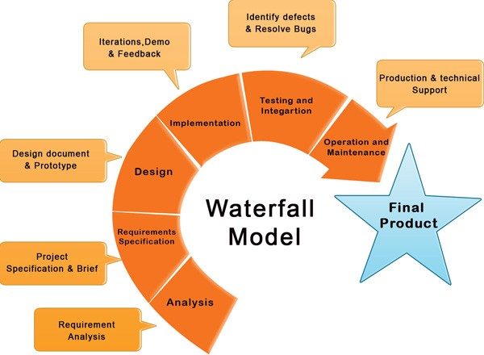

* + 1. **Use Case Diagrams**

**Define Problem**

We are working to develop a complaint management system for the dissatisfied students.

**Define module & Functionality**

The system functions can be described as follows:   
    
**Login:** A student can login by entering their unique User ID and the . The users information such as name , roll no. , hostel-room no. , phone is also entered into computer system for registering complaint.

Register their

complaint

Login -> Generate complaint form

User

**USE CASE 1**

|  |  |  |  |  |  |
| --- | --- | --- | --- | --- | --- |
| Use Case Name:Student Complaint Registration | | | ID: 1 | Priority: High | |
| Actor: Student | | | | | |
| Description: Student register their complaint regarding electricity, carpenter etc. on an online portal . | | | | | |
| Trigger: Student  Type: 🗹External □Temporal | | | | | |
| Preconditions:  1)Student must be already registered on portal by admin.  2)Complaints Datastore must be online.  3)Web Portal must be up-to-date. | | | | | |
| Normal Course:  1)Student sign in to the portal.  2)System verifies the student details from student  information datastore and redirect to  Complaint registration page.  3)Student select the type of complaint to be registered.  4)Student enter all the necessary fields in the  complaint form.  5)System verifies all the details and the complaint is  updated in the respective Complaints datastore.  6)System generates an invoice message on successful  submission. | | | | Information for steps: | |
| Postconditions:  1)Complaints datastore is updated with the new complaint.  2)Student gets an invoice message on successful submission of complaint.  3)Administration is notified of a new complaint. | | | | | |
| Summary  Inputs Source Outputs Destination | | | | | |
| Student name or Id  Complaint Details  Student Authorization | Student  Student  Student Information datastore | Invoice message  Registration Form  Complaint | | | Student  Student  Complaint datastore |

**USE CASE 2**

|  |  |  |  |  |  |  |
| --- | --- | --- | --- | --- | --- | --- |
| Use Case Name:Complaint Management | | | ID: 2 | Priority: High | | |
| Actor: Department Employee | | | | | | |
| Description: Electrician, Plumber, carpenter are notified about complaints in their respective department and update the datastore accordingly. | | | | | | |
| Trigger: Admin  Type: 🗹External □Temporal | | | | | | |
| Preconditions:  1)Department employee must be authenticated.  2)Complaints Datastore must be online.  3)Web Portal must be up-to-date.  4)Login information datastore must be up-to-date. | | | | | | |
| Normal Course:  1)Admin sign in to the portal.  2)System verifies the admin details from login  information datastore and redirect to  Complaint tables.  3)Admin select the type of complaint to be seen.  4)Admin forward the complaint to the respective  department.  5)Each department takes necessary measures to solve the  complaint and report to the admin.  6)Admin updates the complaint status. | | | | | Information for steps: | |
| Postconditions:  1)Complaints status is updated.  2)Admin gets report from department after resolving the complaint.  3)Complainant is informed and the resolved complaint is deleted from datastore. | | | | | | |
| Summary  Inputs Source Outputs Destination | | | | | | |
| Admin name or Id  Request Complaint Table  Update/Delete complaint | Admin  Admin  Admin | Admin Authorization  Complaint Table  Forward Complaint | | | | Web portal  Admin  Department |

**10. Data Flow Diagram(DFD)**

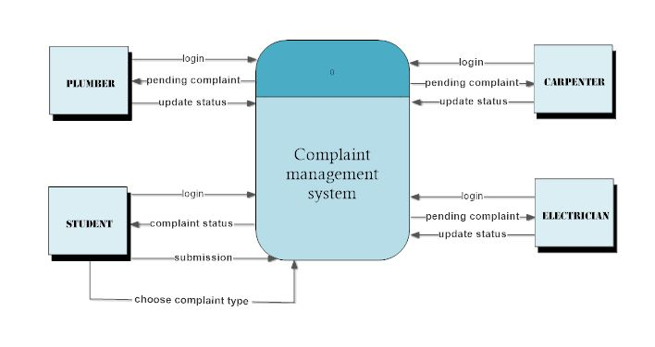

**1st DFD Fragment**

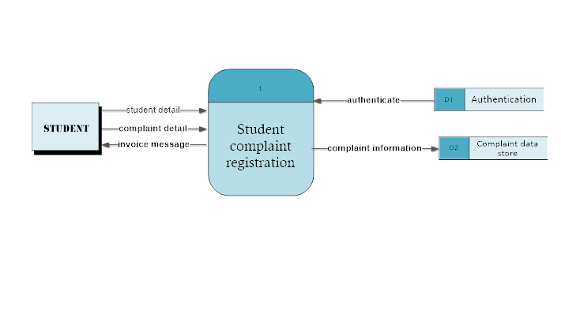

**2nd DFD Fragment**

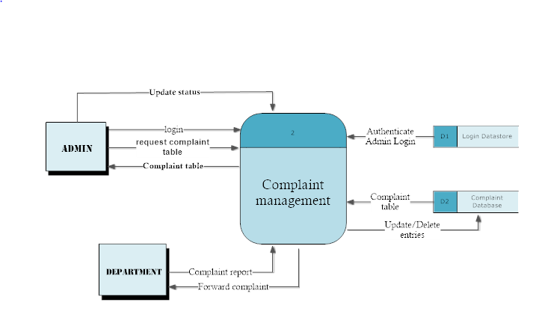

**Level 0 Data Flow Diagram**

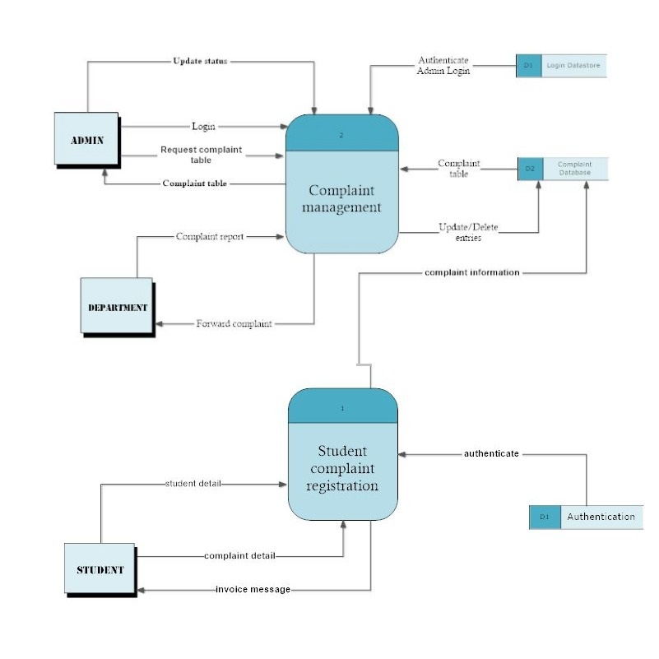

**11. Various Cost In Developing Project**

**Maintenance Cost:**

Maintenance expenses are the costs incurred to keep an item in good condition or good working order. After the deployment of the complaint management system,

New hardware may be required for increasing Database size. Testing and bugs can be managed by the team so no external people are required for maintenance.

**Labour Cost:**

Labor cost management is typically what defines a project as a success or a failure. Budgeting, forecasting and managing the other costs on a project (materials, subcontracts and general conditions) is fairly straightforward, but labor is usually what makes or breaks a job. A good superintendent and a productive workforce typically lead to project successes, while poor or insufficient supervision, coupled with an under-producing workforce are a recipe for financial disaster.

In the development of the project significant amount of work was done by the team.

**Material Cost:**

Normally you think of material as the physical composition of the asset. However, the value of the asset may also include the cost elements of scrap material or manufacturing spares, construction form work and safety items, and the cost of transporting the material to the work site.

**Service Cost:**

The cost of external work that a company seeks for any given project (vendors, contractors, etc.).

**12. Conclusion**

With the help of CMS, complaint of a student can be easily accessed anytime and anywhere whenever needed. In this all the functional and non-functional requirements are specified in order to get a clear cut idea to develop a project.

It is a great improvement over the manual system. The computerization of the system speeds up the process. The software takes care of all the requirements of a student and is capable to provide easy and effective storage of information related to student such as storing data related to test reports and personal information of the patient (i.e. name, roll no.,phone number,room no. etc).The system also provides the facility of backup as per the requirement. The admin can create, update and access complaints whenever they want. The data stored in the complaints datastore is secured with a password set by the admin .Thus, proving that this system is handy, practical and reliable.